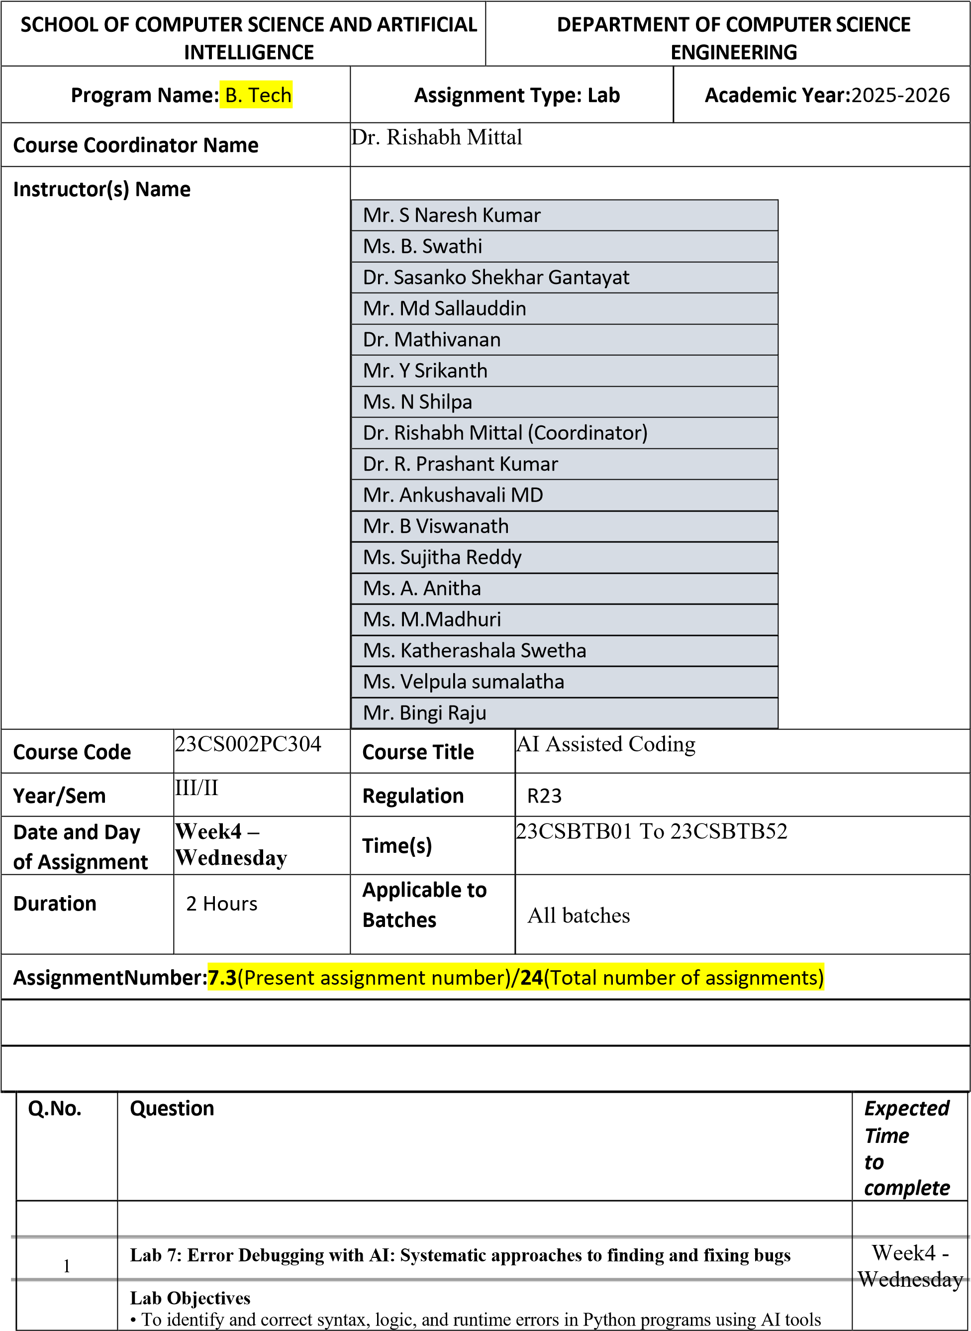
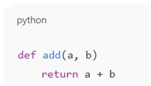
• To understand common programming bugs and AI
-
assisted debugging suggestions

• To evaluate how AI explains, detects, and fixes different types of coding errors

• To build confidence in using AI for structured debugging practices

Lab Outcomes (LOs)

After completing this lab, students will be able to:

• Use AI tools to detect and correct syntax, logic, and runtime errors

• Interpret AI
-
suggested bug fixes and explanations

• Apply systematic debugging strategies using AI
-
generated insights

• Refactor buggy code using reliable programming patterns

Task 1: Fixing Syntax Errors

Scenario

You are reviewing a Python program where a basic function definition contains a syntax error.

Requirements

• Provide a Python function add(a, b) with a
missing colon

• Use an AI tool to detect the syntax error

• Allow AI to correct the function definition

• Observe how AI explains the syntax issue

Expected Output

• Corrected function with proper syntax

• Syntax error resolved successfully

• AI
-
generated explanation of the fix

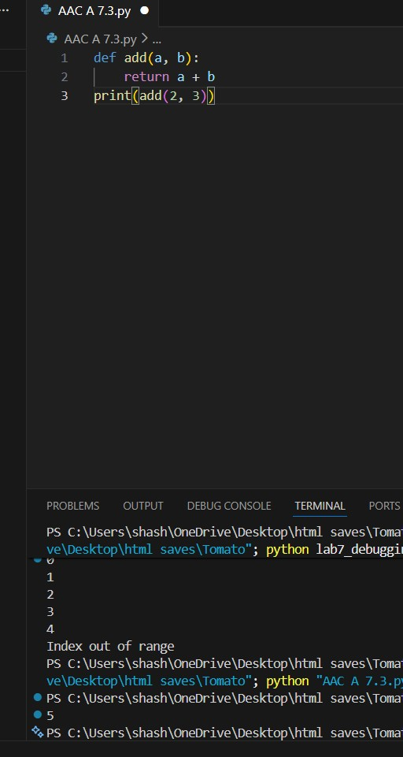

Task 2: Debugging Logic Errors in Loops

Scenario

You are debugging a loop that runs infinitely due to a logical mistake.

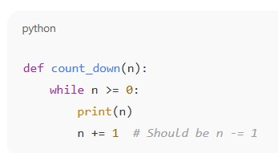

Requirements
- Provide a loop with an increment or decrement error
- Use AI to identify the cause of infinite iteration
- Let AI fix the loop logic
- Analyze the corrected loop behavior

Expected Output
- Infinite loop issue resolved
- Correct increment/decrement logic applied
- AI explanation of the logic error

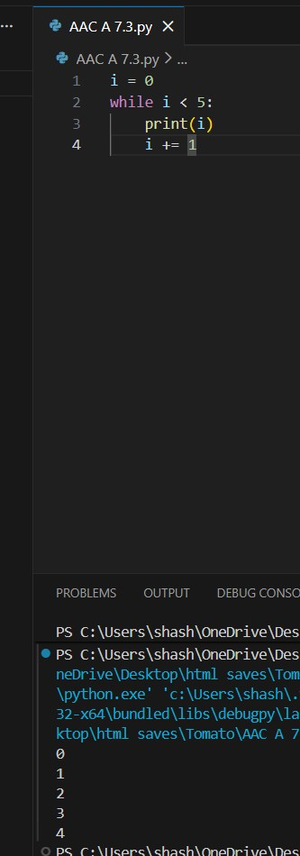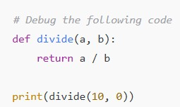

Task 3: Handling Runtime Errors (Division by Zero)

Scenario

A Python function crashes during execution due to a division by zero error.

Requirements

• Provide a function that performs division without validation

• Use AI to identify the runtime error

• Let AI add try
-
except blocks for safe execution

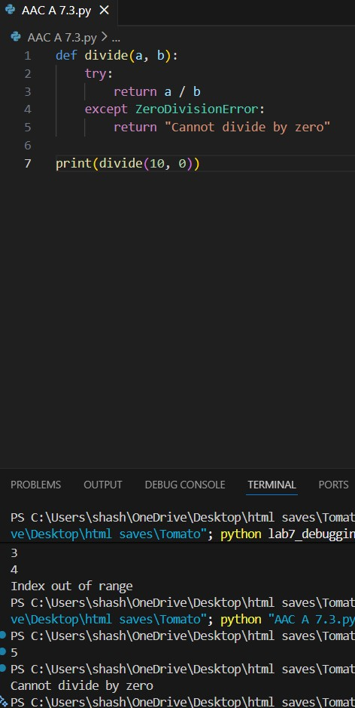
• Review AI’s error
-
handling approach

Expected Output

• Function executes safely without crashing

• Division by zero handled using try
-
except

• Clear AI
-
generated explanation of runtime error handling

Task 4: Debugging Class Definition Errors

Scenario

You are given a faulty Python class where the constructor is incorrectly defined.

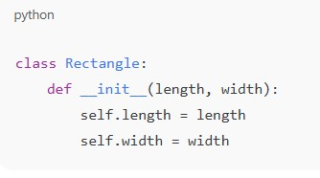

Requirements
- Provide a class definition with missing self-parameter
- Use AI to identify the issue in the __init__() method
- Allow AI to correct the class definition
- Understand why self is required

Expected Output
- Corrected __init__() method
- Proper use of self in class definition
- AI explanation of object-oriented error

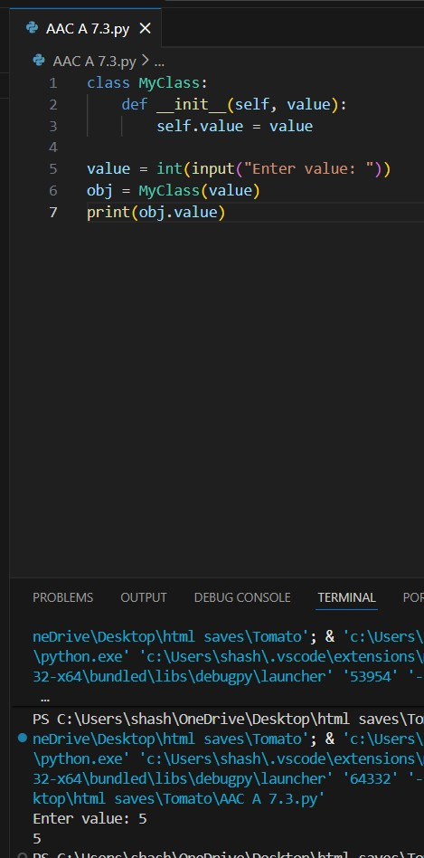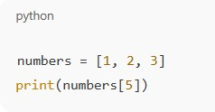

Task 5: Resolving Index Errors in Lists

Scenario

A program crashes when accessing an invalid index in a list.

Requirements

- Provide code that accesses an out-of-range list index
- Use AI to identify the Index Error
- Let AI suggest safe access methods
- Apply bounds checking or exception handling

Expected Output
- Index error resolved
- Safe list access logic implemented
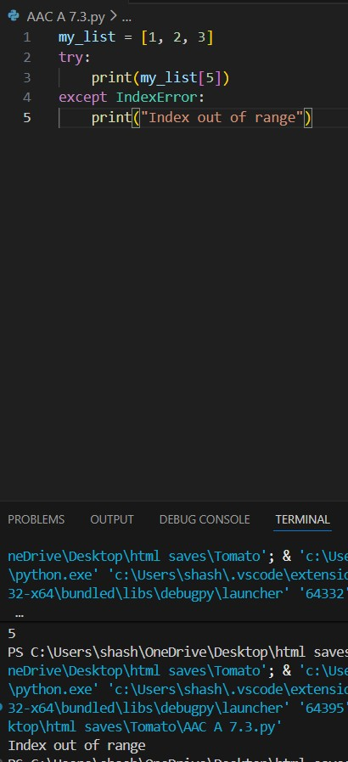
- AI suggestion using length checks or exception handling

Note: Report should be submitted a word document for all tasks in a single document with prompts, comments & code explanation, and output and if required, screenshots

